БЪЛГАРСКИ ЕНЕРГИЕН И МИНЕН ФОРУМ

**BULGARIAN ENERGY & MINING FORUM**

1000 Sofia, 4, Trapezitsa str., Tel/Fax. +359 2 989 89 50 E-mail : office@bulenergo.com, web site : www.bulenergyforum.org

БЪЛГАРСКИ ЕНЕРГИЕН ФОРУМ



**In the framework With the support of**

[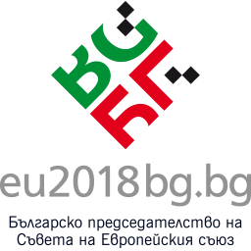](http://eu2018bg.bg/) 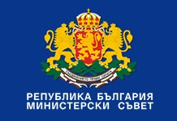

In partnership with

**University of National and World Economy**



**REGISTRATION FORM**

International Conference

***Energy security of South East Europe and the national security***

***15 June 2018***

***Inter Expo Center, Vitosha Hall***

|  |
| --- |
| **Personal name/Company name:**  …………………………………………………………………………………………………………… |
| **Position:** …………………………………………………………………………………………………. |
| **Address, responsible person and company EIC code (required for the invoice)** ………………………………………………………………………………………………………  ……………………………………………………………………………………………………… |
| **I would like accommodation at the Best Western Hotel Expo (located next to the (IEC) from ………..to………June 2018 for ………persons** |
| **E-mail:** ……………………………………………………………………………………………… |

**The participation fee is 360 BGN (180 Euro)** with VAT per person to be paid by **10 June 2018**, which covers all organizational expenses, coffee breaks, the reception and copy of conference proceedings.

There is **20% discount** of the participation fee for early registration **until 30 April 2018.**

**Corporate members of BEMF have a 50% discount of the participation fee.**

**NEW: An option for advertisement of companies and technologies is offered against a fee of 720 EUR for 15 minutes time period during the conference panels, or 360 EUR in poster’ session in the aula of the Conference Hall.**

**Representatives of diplomatic bodies, state administration and academic institutions are exempt of payment fee for 2 representatives of the body.**

*The fees are to be paid through bank transfer to the account of the organizer.*

*Bulgarian Energy & Mining Forum:*

*UniCredit Bulbank, Branch Sveta Negelya,*

*BIC: UNCRBGSF*

*IBAN: BG71UNCR96601075968604*

Electronic invoices will be issued only.

**Please, make sure to indicate your desire to stay at Best Western Hotel Expo, as noted above so we can arrange the reservation for you.**

**All questions about the participation could be forwarded to:** [**office@bulenergo.com**](mailto:office@bulenergo.com)**,** [**bulenergo@gmail.com**](mailto:bulenergo@gmail.com) **on both English or Bulgarian languages.**

**Please, send the completed registration form with copy of the bank transfer order to one of the mentioned e-mail addresses.**

**Any current information related to the event can be asked also by tel/fax: +359 2/98 98 950, or on mobile +359888522776 or at the website of the Forum** [**www.bulenergyforum.org**](http://www.bulenergyforum.org) **and in short time on** [**www.bulenergyconference.org**](http://www.bulenergyconference.org)